

Research School of Finance Actuarial Studies & Statistics

ANU College of Business and Economics

Australian National University

Canberra ACT 2601

<https://www.rsfas.anu.edu.au/>

**RSFAS GROUP ASSIGNMENT COVER SHEET**

Submission and assessment is anonymous where appropriate and possible. Please do not write your name on this coversheet.

This coversheet must be attached to the front of your assessment when submitted in hard copy. If you have elected to submit in hard copy rather than Turnitin, you must provide copies of all references included in the assessment item.

Student ID **(For group assignments, list each student’s ID)**:

U7192040 u7192735

Course Code and Name: FINM7008 Applied investments

Group Number **(Only applicable for group more than one student)**: 97

Assignment Due Date: 14/05/21

Lecturer: **Kun Li**

Word Count: 1279

I declare that this work:

* upholds the principles of academic integrity, as defined in the ANU Policy: Code of Practice for Students [University Academic Misconduct Rules](http://www.anu.edu.au/about/governance/legislation);
* is original, except where collaboration (for example group work) has been authorised in writing by the course convener in the course outline and/or Wattle site;
* is produced for the purposes of this assessment task and has not been submitted for assessment in any other context, except where authorised in writing by the course convener;
* gives appropriate acknowledgement of the ideas, scholarship and intellectual property of others insofar as these have been used;
* in no part involves copying, cheating, collusion, fabrication, plagiarism or recycling.

Signed **(For group assignments, each student must sign):**

Yuyu sui zijian zhen

Dated Submitted: 13/05/21

This report mainly shows how to get the maximum profit of the investment portfolio. So our team chose CCL, CBA, QAN, WBC (represents company A,B,C,D) these four companies and obtained the monthly stock prices of four companies from 2018 to 2020. By calculating the monthly return, excess return, Sharpe ratio, CAMP, and other data of the four companies, the maximum expected return and minimum standard deviation of the optimal risky portfolio are finally calculated, and the efficient frontier curve is drawn, and finally combine the risk-free asset, find the best investment ratio of each company and the maximum expected value of the optimal complete portfolio.

Question 1

We choose the historical performance data from 1/1/2018 to 31/12/2020 (totally 36 months) and divided it by three parts (years) to evaluate four listed companies by calculating four different indexes: return, excess returns, standard deviations, and Sharpe ratios respectively. Overall, in terms of return (averaged), the result shows that A has the highest return among these four companies, which exceed 20% and other companies’ return are around 10%. B ranks last at 8.1%. With the similar expected risk-free return, companies who have higher returns are likely to exist higher expected excess return. Therefore, similarly, A ranks first and B ranks last. As for standard deviation, there are SD of return and SD of excess return separately and based on the calculation results, they are extremely similar. Standard deviation means the risk index corresponding to the company's income. Generally speaking, the higher the risk, the greater the income. However, Company A has the highest return rate but a relatively low risk, which indicates that Company A's operation and sales are superior. Next, Sharpe ratio measures the excess return for each unit of total risk. Thus, Company A has the highest Sharp ratio, in addition, though Company B has the lowest rate of return, its standard deviation is quite low, which makes its Sharpe ratio second only to Company A.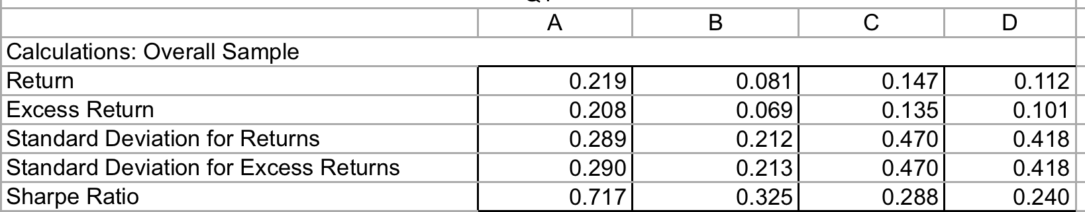

For the three individual years, except for the returns of C and D companies in the last year, the excess returns and Sharpe ratio declined sharply, even to a negative number. In other years, there was little difference with the overall data. Company A still performed the best while Company B performed the worst. In addition, in 2020, Company D's three basic figures are lower than that of Company C, ranking the last among all companies, while Company B rises to the second place.

Question 2

Based on the formula of CAPM model (shown below), we take the excess returns of the four A,B,C,D companies as the Y variable and the market premium as the X variable for regression analysis respectively. Thus, we can get the alpha and beta values under the CAPM model. In terms of the Fama-French 3-Factor Model (shown below), the choice of variable Y is the same as that of CAPM model, while the choice of variable X is required to select market premium, SMB and HML simultaneously. Then, the values of alpha, beta M, beta SMB, beta HML will be calculated.

Furthermore, alpha is used as the excess return rate, and the value of alpha is set to zero under CAPM model. As for the Fama-French 3-factor Model, the excess return of the portfolio will be fully explained by three factors, therefore, alpha should be statistically equal to 0 as well. Hence, we can calculate the expected returns for both CAPM and Fama-French 3-factor Model with alpha equal to zero using the following formula.

According to the two models’ results, company A has the highest alpha, which means it is undervalued and we should invest it since the value of company A will increase in the future. In addition, by comparing the coefficient beta of market portfolio risk premium, size premium and price-to-book premium, it can be seen that Company A has a low beta value in general, except that Company B has a very low size premium and other companies, which means that it has a low systemic risk.

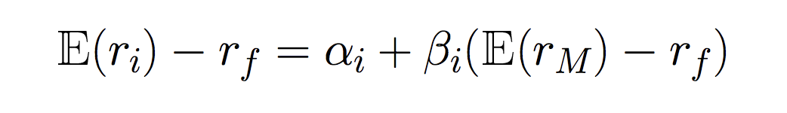



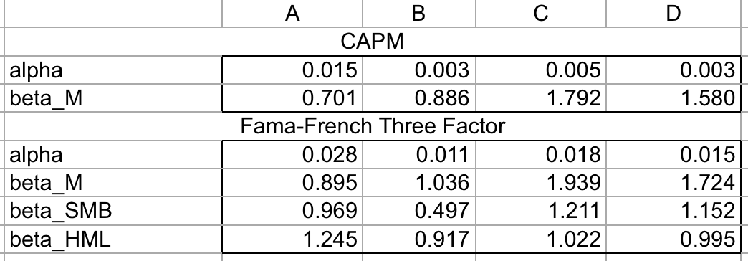

Question 3

After using historical data to calculate variance-covariance matrix and expected return for companies A,B,C,D, for optimal risky portfolio, we are required to enable the Sharp ratio to be the largest. For achieving that, we randomly set the weights of the four companies and determined the expected rate of return, standard deviation, risk-free rate of return and Sharpe ratio of the overall portfolio after allocation by using the previously calculated variance-covariance matrix and expected rate of return (converting monthly historical data into annualised rate of return). Afterwards, the optimal risky portfolio was calculated by Excel Solver. Therefore, we should invest a portfolio (Sharp ratio: 0.723) with 92.6% company A and 7.4% company C.

In terms of minimum variance portfolio, in order to be confronted with the least risk, similar with optimal risky portfolio, using Excel Solver to calculate the weight and minimum standard deviation (0.243) of the portfolio (72.2%A, 23%B, 4.8%C, respectively).

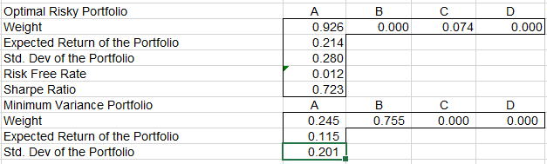

As for the efficient frontier, it illustrates that nine different portfolios from the expected return is 0.1 to 0.4, with an interval of 0.005. Thus, the portfolio which the expected return is 0.115 is the global minimum variance portfolio.

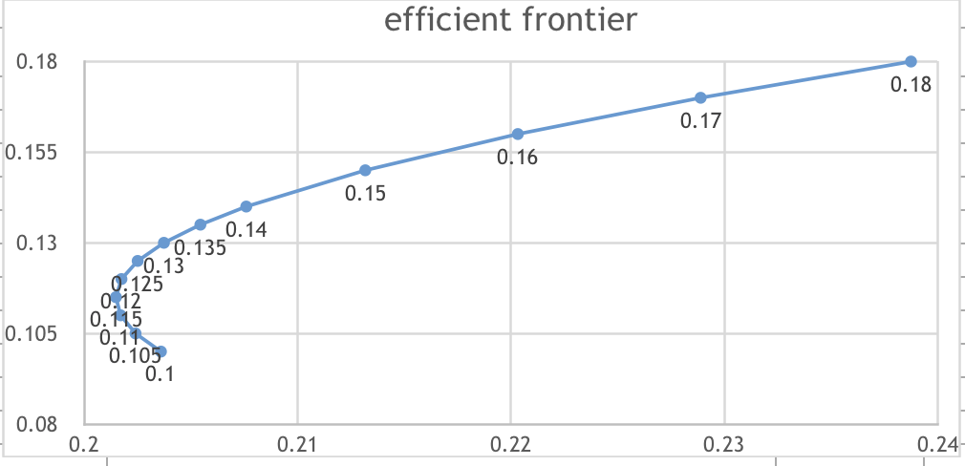

Question 4

In order to calculate the proportional to the risky assets, we use the following formula with calculated expected rate of return, standard deviation, risk-free rate of return in question 3 and given risk aversion. The result for y* is 0.861, hence, we can calculate four companies’ weight by times optimal risk portfolio weight and the risk-free rate equals to 0.139 (1- y*).

Furthermore, for calculating the expected return of the completed portfolio, we use the risky assets weight times the expected return of optimal risky portfolio plus risk-free weight times the return of risk-free rate—the result is 0.186. For standard deviation, since the variance of risk-free equals to 0, thus, the result is 0.861*0.28=0.241.

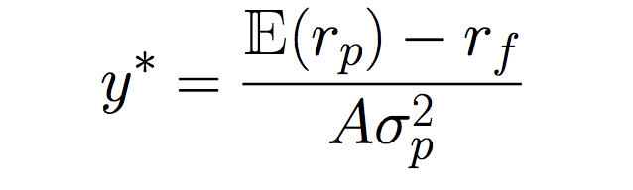

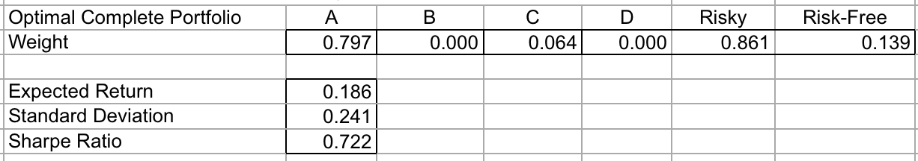

The line of possible portfolio risk and return combinations is referred as capital allocation line. The slope of the line is Sharp ratio. The CAL and efficient frontier are shown below, as we can see, the point of tangency is the optimal risky portfolio, which means the expected return is 18.6%. Therefore, as a rational investor, we should invest in the complete optimal portfolio of risky assets and risk-free assets corresponding to this tangency point. If investors is likely to achieve higher returns, it should use leverage to borrow money from a risk-free asset and move it into a risky asset (risk-free borrowing). This is shown in the chart to the right of the tangency point on the CAL line.

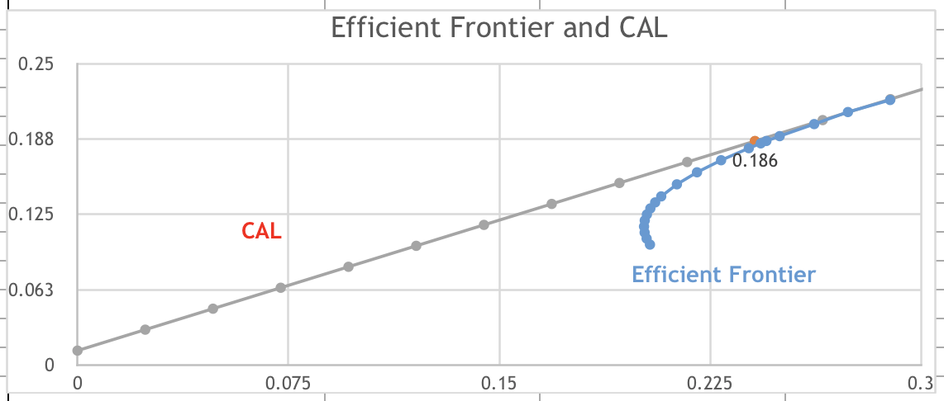

Question 5

According to the optimal investment portfolio we calculated before, we can really realise the importance of diversification of risk. After diversification of risk, the standard deviation AND Sharpe ratio are all higher than that of just investing in a single company. However, as can be seen, the expected return of portfolio has decreased compared with CCL, which means to some extent, high risk leads to high return. Thus, for risk-seeking, they may choose to invest some high risky projects like angel investment and venture investments.

In conclusion, among the four companies we selected, based on the comparison of excess return rate, standard deviation, Sharpe ratio, CAPM model and other indicators, the comprehensive performance of single company of CCL is the best, while that of CBA is the worst. As mentioned before, in order to diversify risks and maximise returns, we determine the proportion of each company and risk-free assets by building portfolios to obtain the optimal risk portfolio (0.861 risky, 0.139 risk-free, respectively). Finally, the effective front line and CAL are clearly presented by drawing charts.

Reference

https://finance.yahoo.com/